**Exercise 3: Stored Procedures**

**Scenario 1:** The bank needs to process monthly interest for all savings accounts.

* + **Question:** Write a stored procedure **ProcessMonthlyInterest** that calculates and updates the balance of all savings accounts by applying an interest rate of 1% to the current balance.

CREATE TABLE SavingsAccounts (

AccountID INT PRIMARY KEY,

CustomerID INT,

Balance NUMBER(10,2)

);

INSERT INTO SavingsAccounts VALUES (201, 1, 10000);

INSERT INTO SavingsAccounts VALUES (202, 2, 20000);

COMMIT;

CREATE OR REPLACE PROCEDURE ProcessMonthlyInterest IS

BEGIN

FOR acc IN (SELECT AccountID, Balance FROM SavingsAccounts) LOOP

UPDATE SavingsAccounts

SET Balance = Balance + (Balance * 0.01)

WHERE AccountID = acc.AccountID;

END LOOP;

DBMS_OUTPUT.PUT_LINE('Monthly interest applied to all savings accounts.');

END;

/

SET SERVEROUTPUT ON;

EXEC ProcessMonthlyInterest;

SELECT * FROM SavingsAccounts;

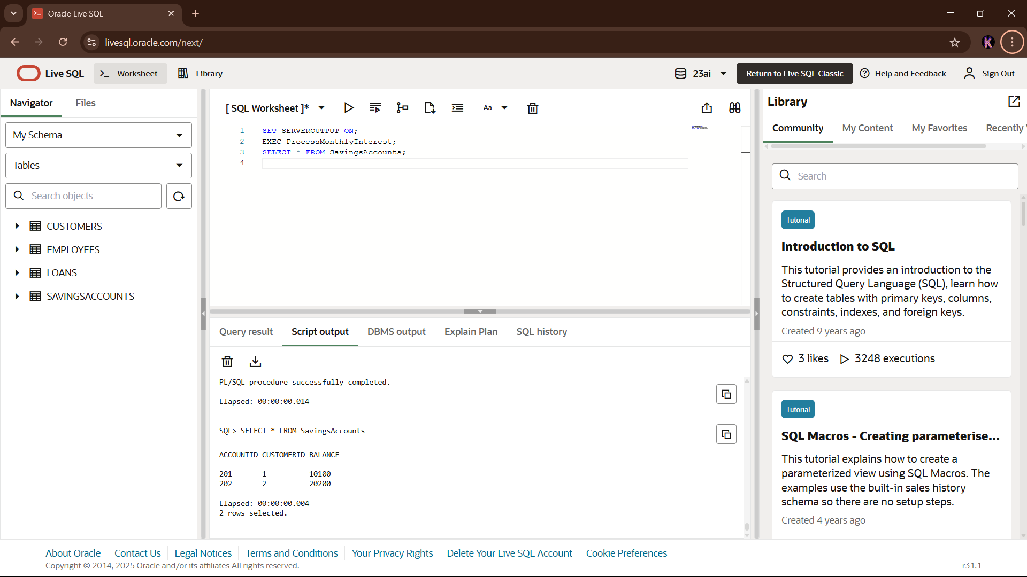

**Scenario 2:** The bank wants to implement a bonus scheme for employees based on their performance.

**Question:** Write a stored procedure **UpdateEmployeeBonus** that updates the salary of employees in a given department by adding a bonus percentage passed as a parameter

CREATE TABLE Employees (

EmployeeID INT PRIMARY KEY,

Name VARCHAR2(100),

Department VARCHAR2(50),

Salary NUMBER(10,2)

);

INSERT INTO Employees VALUES (301, 'John', 'HR', 50000);

INSERT INTO Employees VALUES (302, 'Alice', 'IT', 60000);

INSERT INTO Employees VALUES (303, 'Mike', 'HR', 55000);

COMMIT;

CREATE OR REPLACE PROCEDURE UpdateEmployeeBonus (

p_department IN VARCHAR2,

p_bonus_pct IN NUMBER

) IS

BEGIN

UPDATE Employees

SET Salary = Salary + (Salary * p_bonus_pct / 100)

WHERE Department = p_department;

DBMS_OUTPUT.PUT_LINE('Bonus applied to department: ' || p_department);

END;

/

SET SERVEROUTPUT ON;

EXEC UpdateEmployeeBonus('HR', 10);

SELECT * FROM Employees;

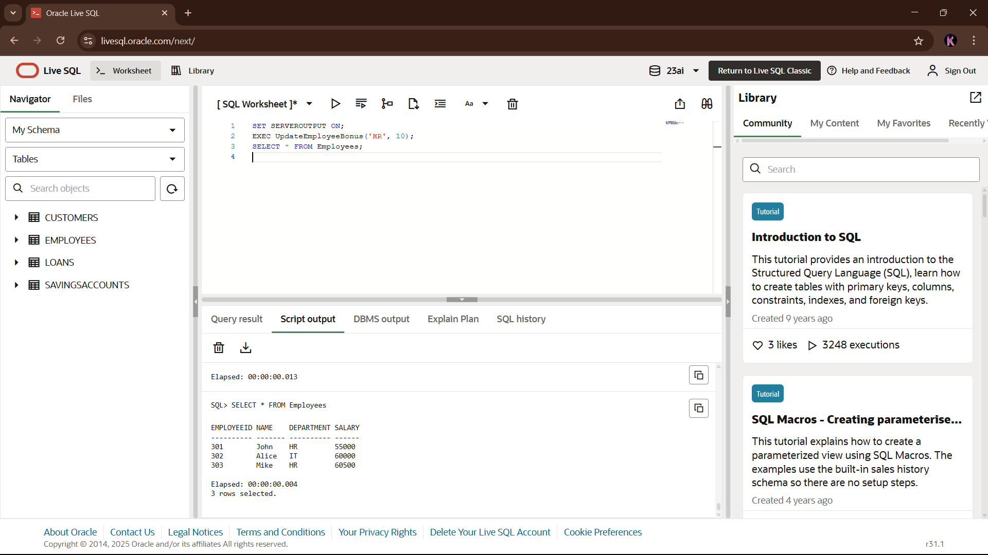

**Scenario 3:** Customers should be able to transfer funds between their accounts.

* + **Question:** Write a stored procedure **TransferFunds** that transfers a specified amount from one account to another, checking that the source account has sufficient balance before making the transfer.

CREATE TABLE Accounts (

AccountID INT PRIMARY KEY,

CustomerID INT,

Balance NUMBER(10,2)

);

INSERT INTO Accounts VALUES (101, 1, 1000);

INSERT INTO Accounts VALUES (102, 2, 2000);

COMMIT;

CREATE OR REPLACE PROCEDURE TransferFunds (

p_from_account IN INT,

p_to_account IN INT,

p_amount IN NUMBER

) IS

v_balance NUMBER;

BEGIN

SELECT Balance INTO v_balance FROM Accounts WHERE AccountID = p_from_account;

IF v_balance < p_amount THEN

RAISE_APPLICATION_ERROR(-20001, 'Insufficient funds.');

END IF;

UPDATE Accounts

SET Balance = Balance - p_amount

WHERE AccountID = p_from_account;

UPDATE Accounts

SET Balance = Balance + p_amount

WHERE AccountID = p_to_account;

DBMS_OUTPUT.PUT_LINE('Transferred ' || p_amount ||

' from Account ' || p_from_account ||

' to Account ' || p_to_account);

END;

/

SET SERVEROUTPUT ON;

EXEC TransferFunds(101, 102, 500);

SELECT * FROM Accounts;

